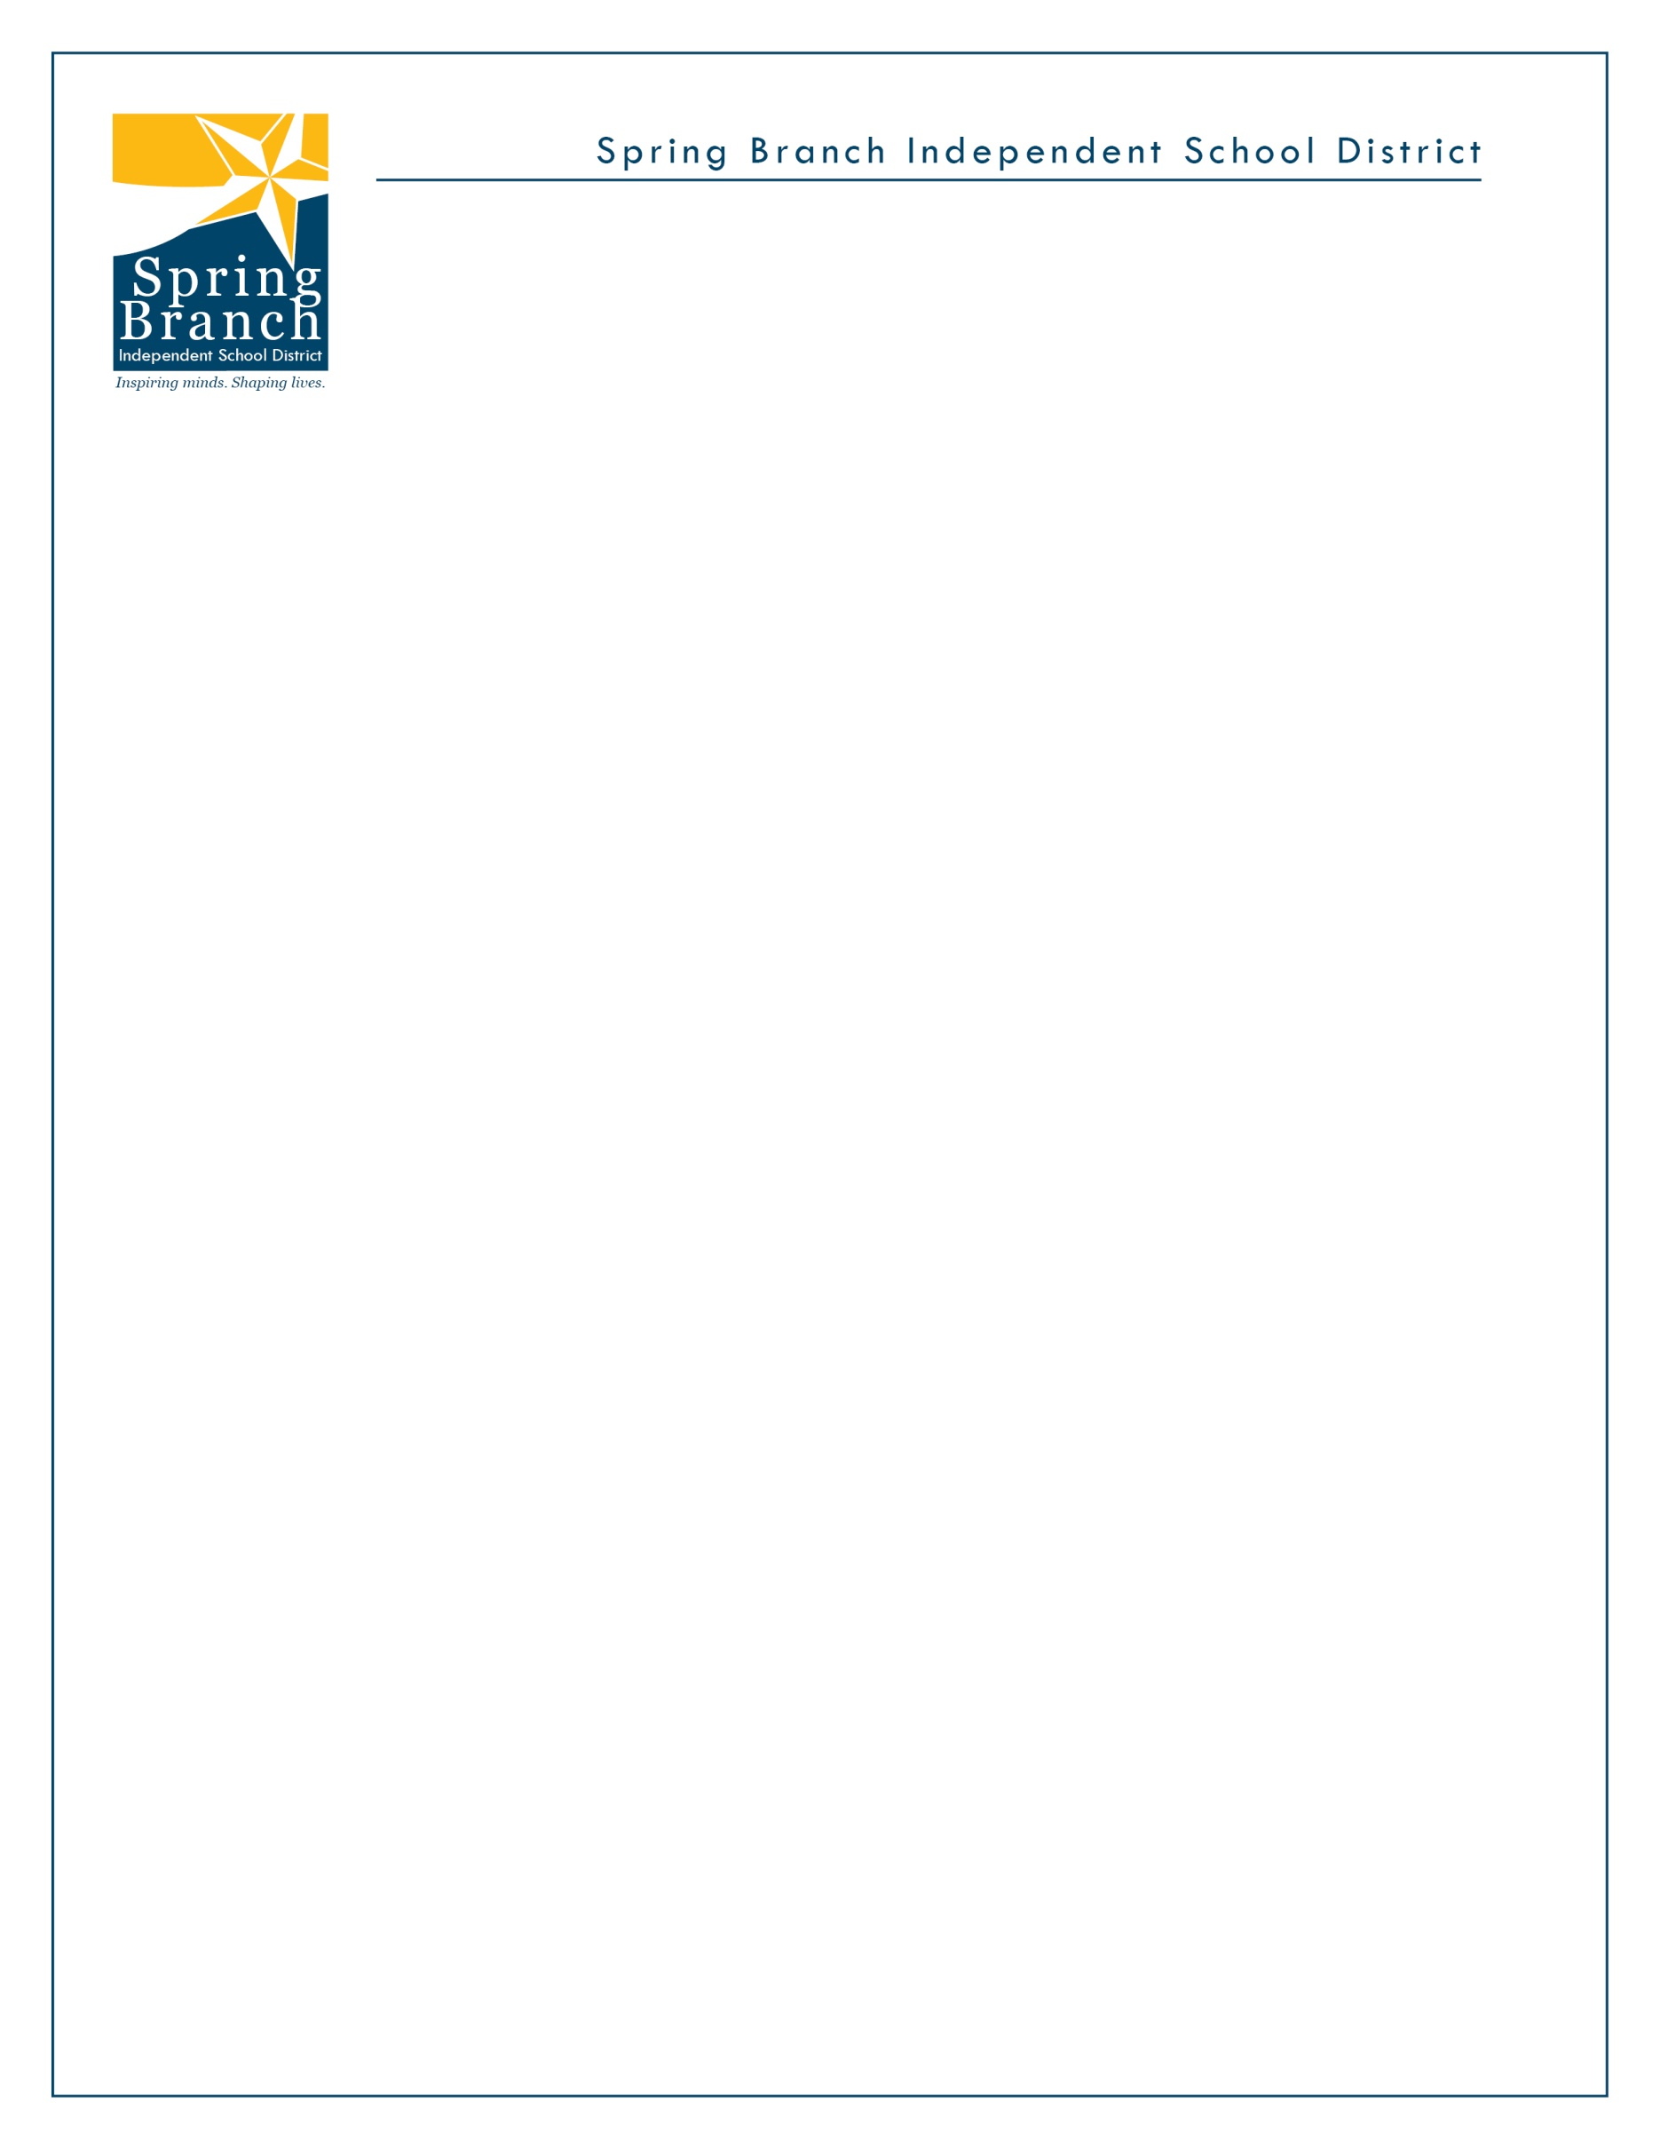

**THORNWOOD ELEMENTARY**

**2020-2021 Supply List by Grade Level**

**Pre-K- Kindergarten**

|  |  |  |  |
| --- | --- | --- | --- |
| 1 | Headphones (no earbuds) | 3 | **2 Boxes 24 ct Crayola Crayons** and **1 Crayola Watercolor Paint-8 count** |
| 1 | Set of Washable Crayola Markers | 2 | Pink Erasers |
| 1 | 12 ct Re-Closable quart bags, 12 ct. Sandwich Size | 9 | Glue Sticks |
| 12 | # 2 Ticonderoga Sharpened Pencils | 2 | **1** Hand Sanitizer **1** Baby wipes |
| 2 | 175 ct Kleenex Tissues | 12 | Ziploc Gallon Size Bags |
| 1 | Pack of EXPO Dry-Erase Markers - 4 pack | 2 | 120 ct Spiral Notebooks **Wide Ruled** |
| 3 | Plastic Pocket Folders with Brads (1 Red, 1 Green, 1Yellow) | 1 | Ream of copy Paper |
| 2 | Packages of 12x18 Manila Paper | 1 | Package of 12x18 White Drawing Paper |
| 2 | Packages of 12x18 Construction Paper | 1 | Plastic Supply Box |
| 1 | Mead Writing Journal - Primary | 1 | Fiskars Scissors |

**1st Grade**

|  |  |  |  |
| --- | --- | --- | --- |
| 1 | Headphones (over the ear- **NO EARBUDS**) | 1 | Ream of White Copy Paper |
| 1 | Packages of Manila Construction paper 12x18 | 1 | Hand sanitizer 32oz size |
| 3 | Large boxes of Facial Tissue 100 ct. | 2 | Tube of Disinfecting Wipes |
| 3 | Boxes of Ziploc bags - 2 Gallon size, 1quart | 3 | Boxes of 24 ct Crayola Crayons |
| 10 | Spiral Notebooks - **Wide Ruled ( 2yellow, 2blue, 2green, 2red, 2 Purple)** | 4 | Plastic Folders with pockets and brads (1 Yellow, 1 Green, 1 Blue, & 1 Red) |
| 24 | #2 pencils - Ticonderoga Sharpened, or American | 16 | Glue Sticks **NO LIQUID GLUE** |
| 2 | Packs of 4x6 index cards 100ct. | 1 | Packs of Colored Construction Paper 12x18 |
| 1 | Scissors | 3 | Large pink erasers |
| 1 | Packs of Wide Ruled Notebook Paper | 1 | Plastic School Supply box |
| 2 | Post It Notes Pack of 4 (3X3 Yellow) | 3 | Pack of EXPO Dry-Erase Markers |
| 1 | 25pk of Sheet Protectors |  |  |

**2nd Grade * Colors listed are very important in helping your child stay organized**

|  |  |  |  |
| --- | --- | --- | --- |
| 3 | Boxes of 24 ct Crayola Crayons | 1 | Pack of 12x18 Color Construction Paper |
| 1 | Pack of 12x18 White Construction Paper | 1 | Ream of White Copy Paper |
| 1 | Plastic School Box | 2 | Post It Notes Pack of 4 (3X3 Yellow) |
| 8 | 70 ct Spiral **Wide Rule** Notebooks (2 green, 2 blue, 2 red, and 2 yellow) **NOT COLLEGE RULE!** | 9 | **Plastic** Pocket Folders w/Brads (3Green, 3Yellow, 3Red) |
| 6 | Large Elmer’s Glue Sticks | 3 | 100 ct Facial Tissue |
| 36 | #2 Pencils Ticonderoga Sharpened Brand | 1 | Box of Baby or Disinfectant Wipes |
| 2 | Pack of Wide Ruled Notebook Paper | 3 | Pink Paper Mate Erasers |
| 1 | Packs of 4 ct EXPO White Board Markers | 2 | Boxes Ziploc Bags (1Gallon and 1 Quart size) |
| 1 | Packs of 12x18 Manila Paper | 1 | Scissors |
| 1 | Pack of Sheet Protectors | 1 | Bottle of Hand Sanitizer |

*Inspiring minds. Shaping lives.*